Part I

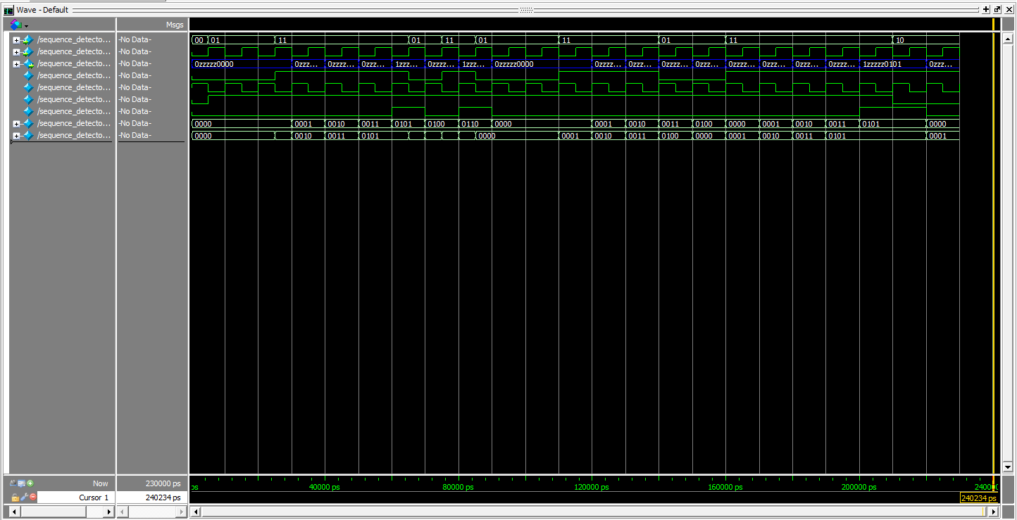

Clock

Z (LEDR[9])

W (SW[1])

{W, Reset}

Reset (sync)

A to F

D to E

then

E to A

A to D

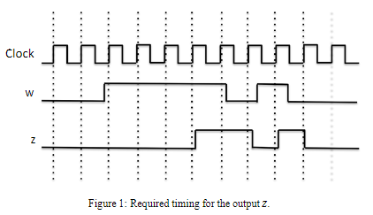

Part II

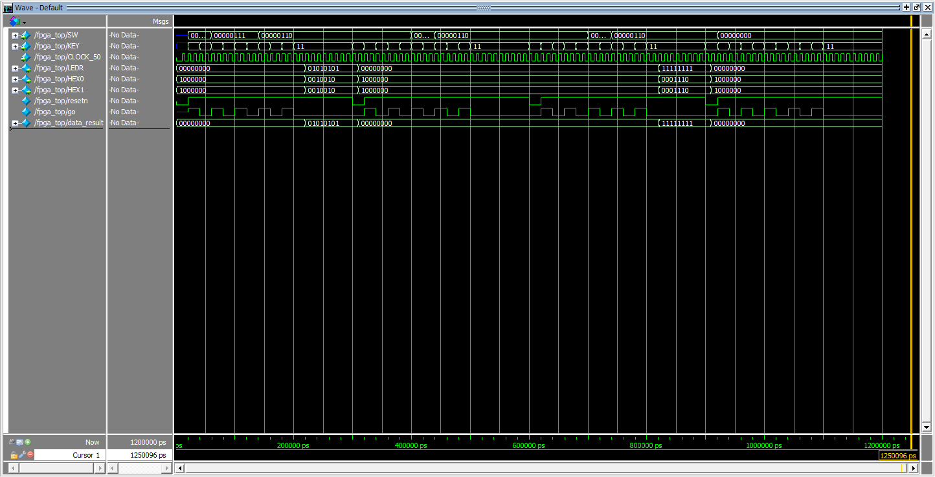

Answer

A=0, B=0, C=0, X=0

Ans=0=7’b0

A=6, B=6, C=3, X=6

Ans=255=7’b11111111

A=6, B=6, C=4, X=6

Ans=256=8’b100000000

=7’b0

A=1, B=7, C=7, X=6

Ans=85=7’b01010101

RTL Schematic

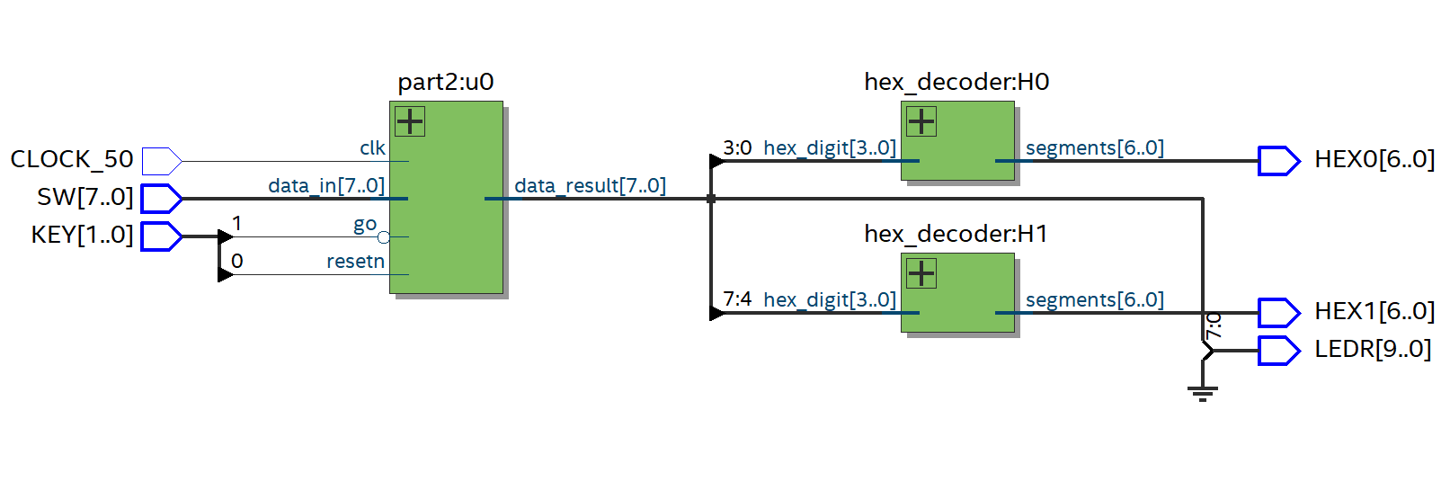

State Diagram

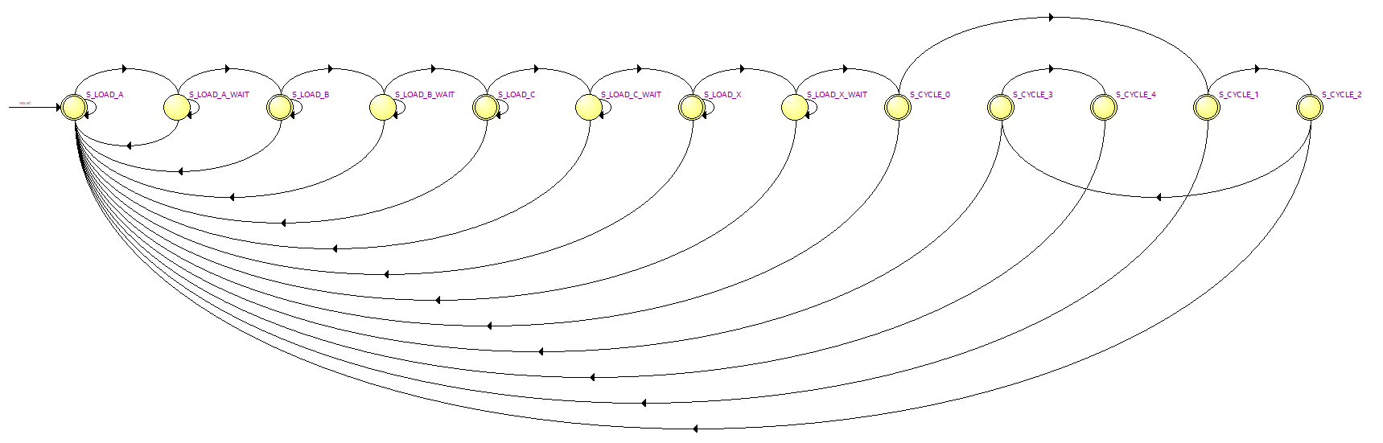

State Table

|  |  |  |
| --- | --- | --- |
| **Source State** | **Destination State** | **Condition** |
| S_CYCLE_0 | S_CYCLE_1 | (resetn) |
| S_CYCLE_0 | S_LOAD_A | (!resetn) |
| S_CYCLE_1 | S_CYCLE_2 | (resetn) |
| S_CYCLE_1 | S_LOAD_A | (!resetn) |
| S_CYCLE_2 | S_CYCLE_3 | (resetn) |
| S_CYCLE_2 | S_LOAD_A | (!resetn) |
| S_CYCLE_3 | S_CYCLE_4 | (resetn) |
| S_CYCLE_3 | S_LOAD_A | (!resetn) |
| S_CYCLE_4 | S_LOAD_A |  |
| S_LOAD_A | S_LOAD_A_WAIT | (go)(resetn) |
| S_LOAD_A | S_LOAD_A | (!go) + (go)(!resetn) |
| S_LOAD_A_WAIT | S_LOAD_B | (!go)(resetn) |
| S_LOAD_A_WAIT | S_LOAD_A_WAIT | (go)(resetn) |
| S_LOAD_A_WAIT | S_LOAD_A | (!resetn) |
| S_LOAD_B | S_LOAD_B_WAIT | (go)(resetn) |
| S_LOAD_B | S_LOAD_B | (!go)(resetn) |
| S_LOAD_B | S_LOAD_A | (!resetn) |
| S_LOAD_B_WAIT | S_LOAD_C | (!go)(resetn) |
| S_LOAD_B_WAIT | S_LOAD_B_WAIT | (go)(resetn) |
| S_LOAD_B_WAIT | S_LOAD_A | (!resetn) |
| S_LOAD_C | S_LOAD_C_WAIT | (go)(resetn) |
| S_LOAD_C | S_LOAD_C | (!go)(resetn) |
| S_LOAD_C | S_LOAD_A | (!resetn) |
| S_LOAD_C_WAIT | S_LOAD_X | (!go)(resetn) |
| S_LOAD_C_WAIT | S_LOAD_C_WAIT | (go)(resetn) |
| S_LOAD_C_WAIT | S_LOAD_A | (!resetn) |
| S_LOAD_X | S_LOAD_X_WAIT | (go)(resetn) |
| S_LOAD_X | S_LOAD_X | (!go)(resetn) |
| S_LOAD_X | S_LOAD_A | (!resetn) |
| S_LOAD_X_WAIT | S_LOAD_X_WAIT | (go)(resetn) |
| S_LOAD_X_WAIT | S_CYCLE_0 | (!go)(resetn) |
| S_LOAD_X_WAIT | S_LOAD_A | (!resetn) |